A step by step guide for running the matlab code

1. For generating cepstrum frames you need to either use phase1_eec201_1.m or phase2_eec201_1.m. Replace the address your file address. The frame_length and overlap_length is set in seconds.

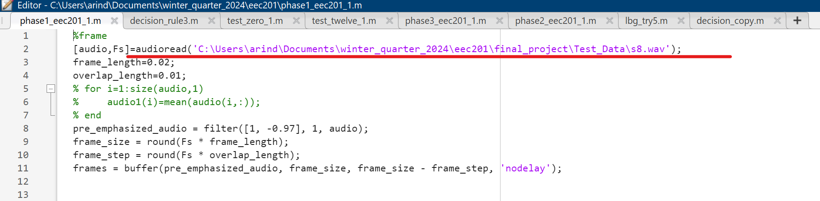

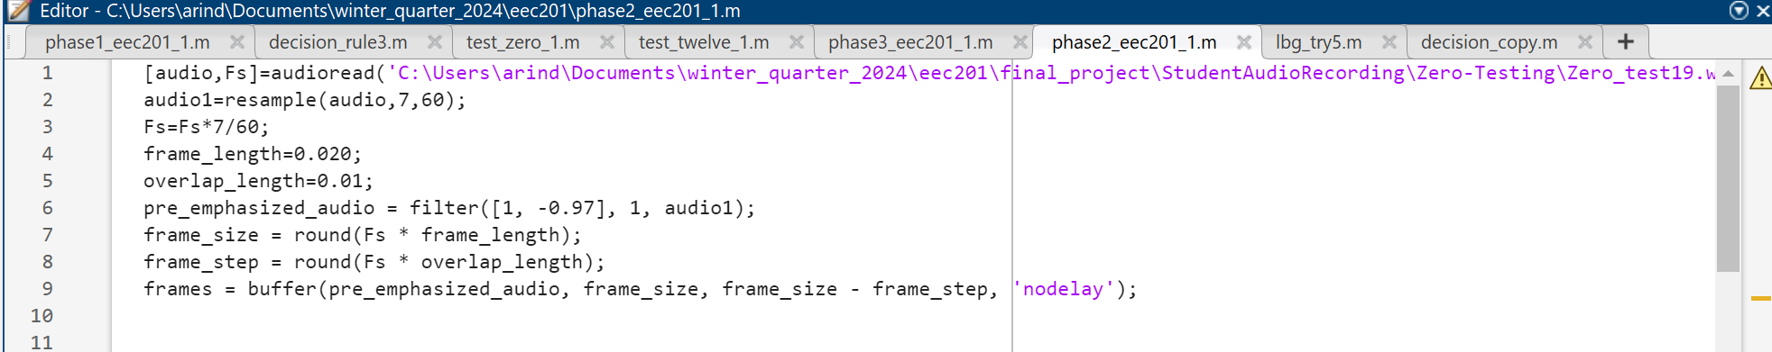

In phase2_eec201_1.m the entered dataset goes through a resampling to 5600Hz. Change as the input requires.

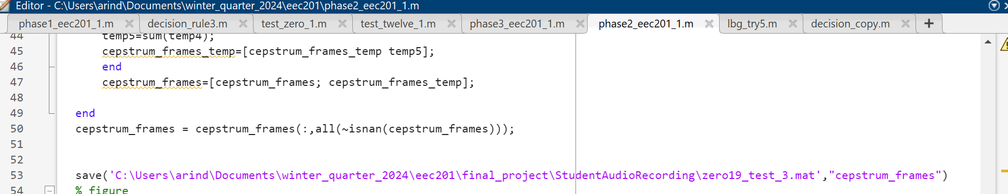

Both the codes will save the frames formed by MFCC in your given address.

1. To generate centroid by vector quantization one needs to use the lbgtry5.m file

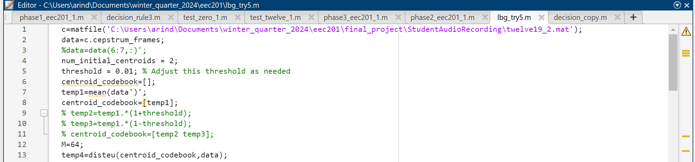 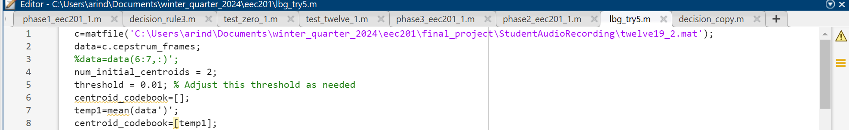

Enter the address of save MFCC frames and set the required number of centroids to M variable. It needs to be noted that the number of centroid doubles in every splitting, hence if 60 centroids are entered, 64 centroids would be saved.

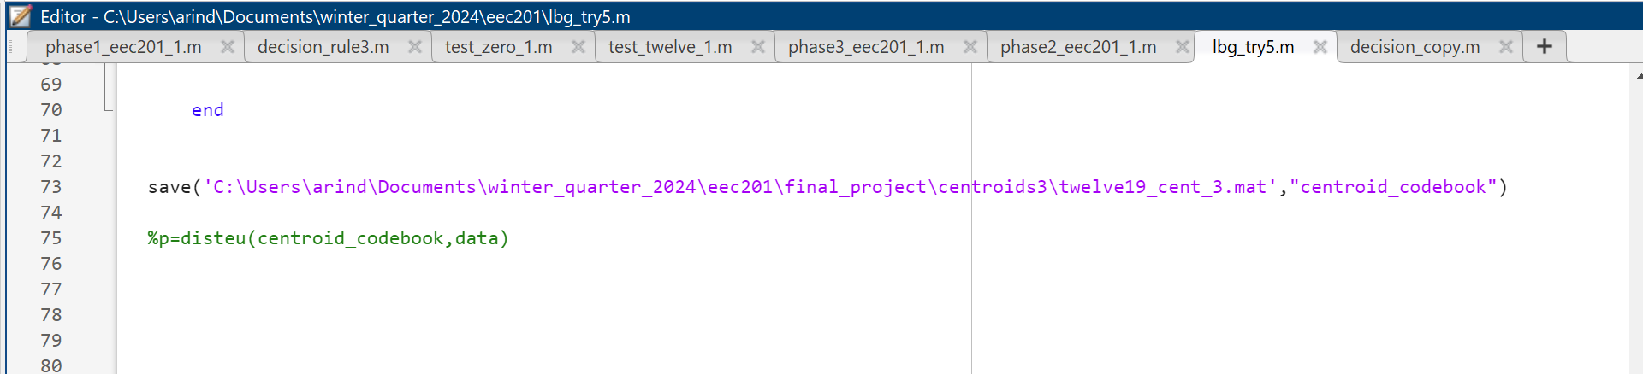

The centroids are saved in one’s preferred location

1. For testing 3 different code books are used decision_rule3.m, test_zero_1.m and test_twelve_1.m

First you need to import all your centroids

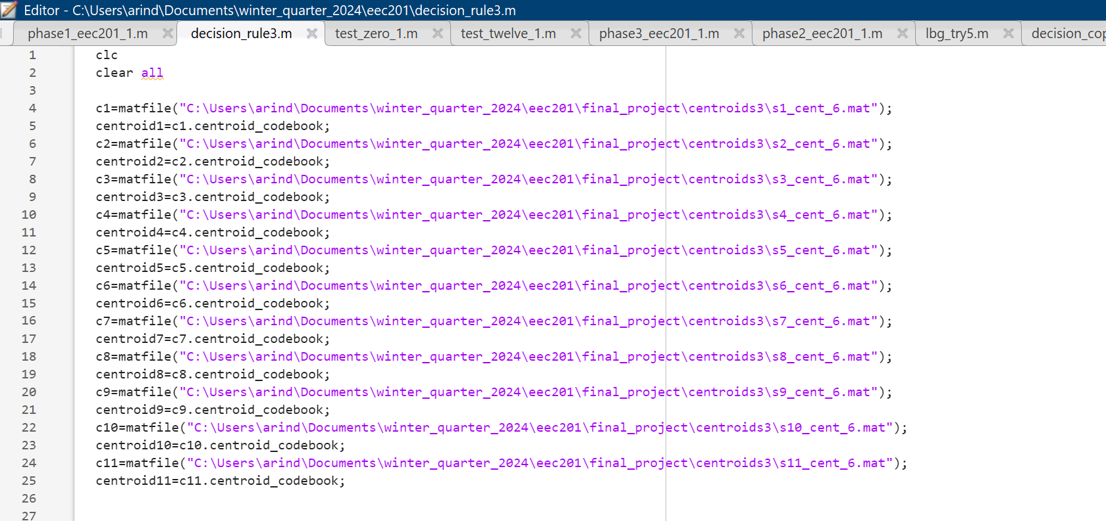

Then you need to import the cepstrum frames of the test signal

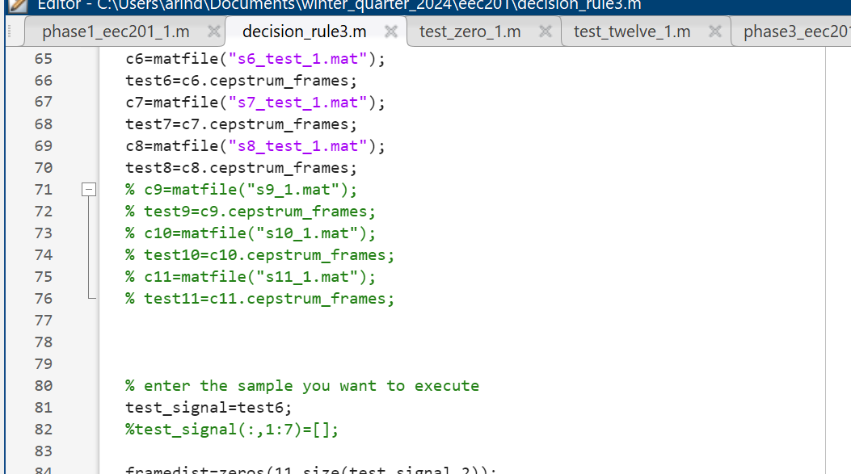

Just hit run once done, and the code will print its output.